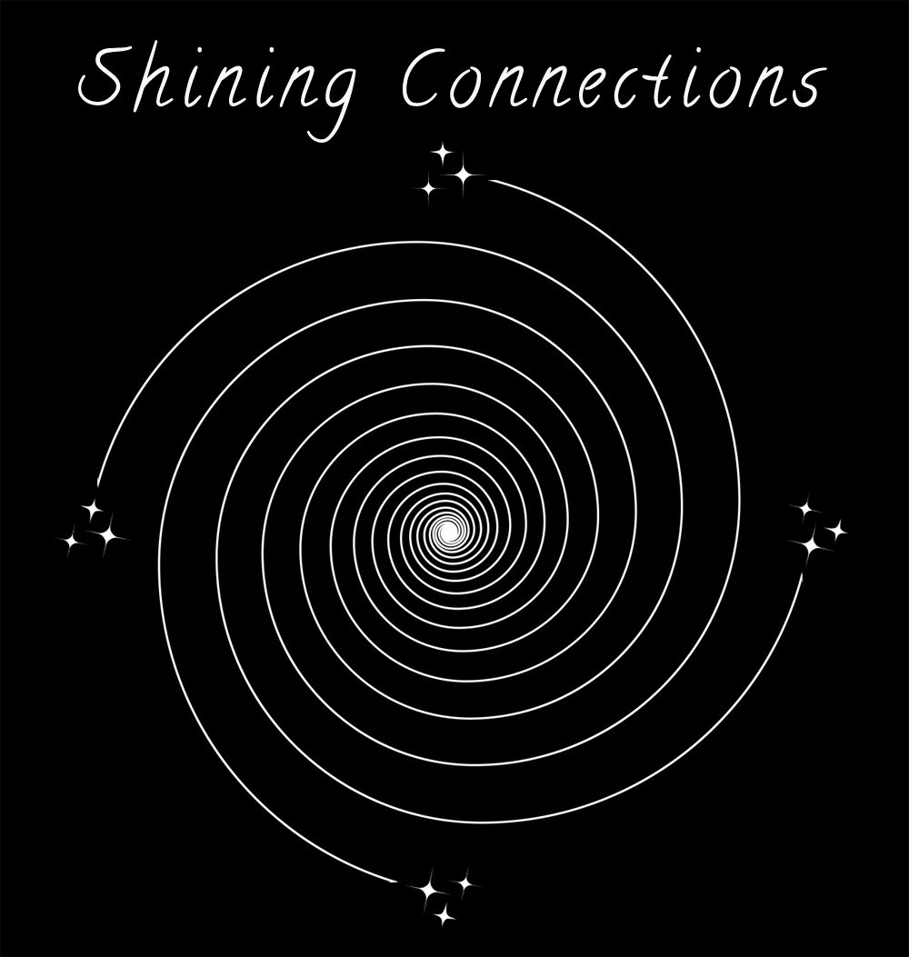 Candace Leila, 707.972.0606
shiningconnection.com | shining.one@icloud.com

WEDDING CEREMONY CHECKLIST
Beloved 1 full name:
Beloved 2 full name:
Age of Beloved 1:
Age of Beloved 2:
Address:
Phone number:
Email Address:
Date and time of ceremony:
Ceremony Location:
Rehearsal Date & Time:
Number of guests:
Coordinator Phone Number:
Where do you live?
Do you live together?
First Marriage?
Children?
Pets?
How long have you been a couple?
How did you meet?
How long engaged?
Who Proposed?
How would you describe your relationship?
What do you consider important or unique (bride and groom answer separately)?
Education? (bride and groom answer separately)
Occupation? (bride and groom answer separately)
Style (please circle and elaborate): Traditional / Religious / Spiritual / Elegant / Simple / Contemporary / Inter-faith / Non-denominational
Ritual Ceremonies (please circle and elaborate): Vows / Parent's Vow / Children's Vows / Ring exchange / Water blessing / Unity lighting of candles / Memorial candles / Sharing of food or wine / Bell ringing / Hand ceremony / Love letter Box / Sand ceremony / Rose ceremony / Catholic lazo / Jewish breaking of glass / Butterfly release / Jumping the broom / Smudging / Calling in of Directions /Hand Fasting
Colors:
Style of Clothing:
Flowers:
Music:
Altar:
Program:
Photographer:
Videographer:
Beloved 1’s Mother:
Occupation:
Beloved 1’s Father:
Occupation:
Beloved 1’s Siblings:
Beloved 2’s Mother:
Occupation:
Beloved 2’s Father:
Occupation:
Beloved 2’s Siblings:
Special Guests:
Out of state:
In Remembrance?
Maid of Honor:
Bridesmaids:
Attendants:
Best Man:
Groomsmen:
Attendants:
Ushers:
Flower girl:
Ring Bearer:
Style of ring:
Processional (order of go):
Welcome (Minister Adapts according to ceremony space, gathering and weather):
Opening Blessing (see choices under shiningconnection.com/ wedding1/opening-blessings):
Ministers Blessing (developed together):
Readings (see choices under shiningconnection.com/wedding1/readings):
Expression of Intent (see choices under shiningconnection.com/wedding1/intent):
Vows (see choices under shiningconnection.com/wedding1/vows):
Repeat after me or cheat sheet?
Friends and Family Vow of Support?
Rings (see choices under shiningconnection.com/wedding1/rings):
Closing Blessing (see choices under shiningconnection.com/wedding1/closing-blessing):
Proclamation (see choices under shiningconnection.com/wedding1/proclamation):
Mr. And Mrs. / Retain last names / Hyphen
Kiss (see choices under shiningconnection.com/wedding1/kiss):
Toast:
Reception:
Witness One:
Address:
Witness Two:
Address:
Please Bring Wedding License with envelope to rehearsal:
What County?
Certified or Non?
Honeymoon:
Invitation:
Minister’s attire (Robe / Suit / Dress):
My Services include: Initial consultation / 1 hour Personal meeting and interview with couple / Unlimited, ongoing communication with couple and wedding site organizers / Personalized crafted ceremony / Rehearsal / Coordinate processional as necessary / Wedding ceremony (arrival 1/2 hour early) / Signing and mailing of License and Marriage certificate / Keepsake Copy of Ceremony
Any additional information you want to share:

